**TC CLIENT INSTALLATION**

**1.** Run tem.bat from 11.6.0_patch of TC CLIENT SOFT directory

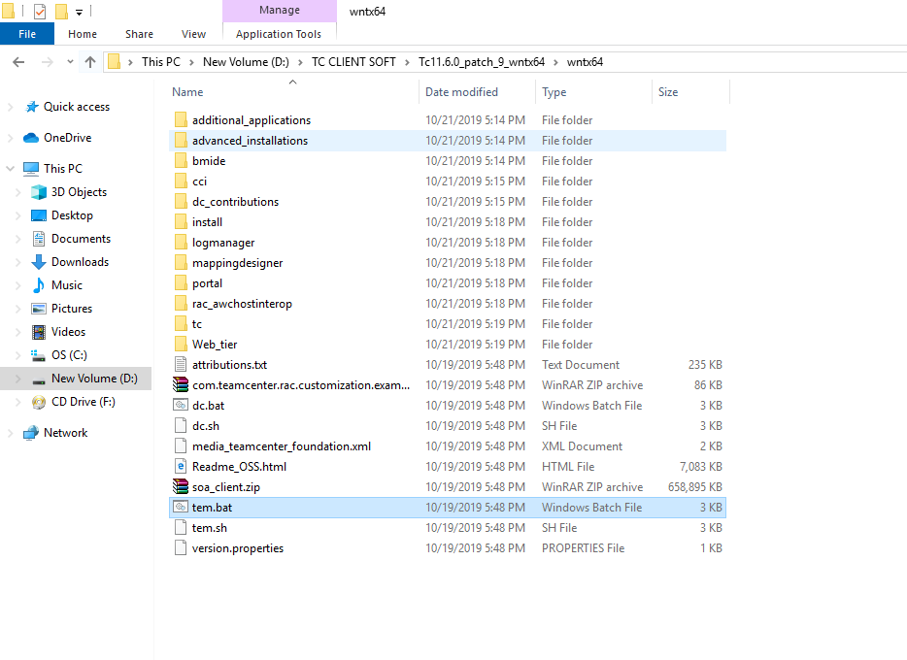

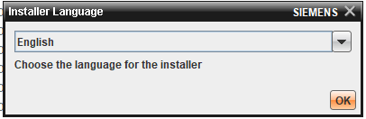

**2.** Select Teamcenter Rapid Start

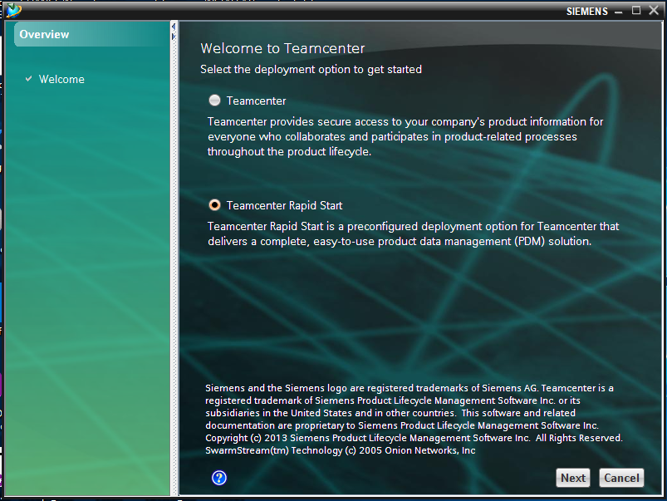

**3.** Select Install

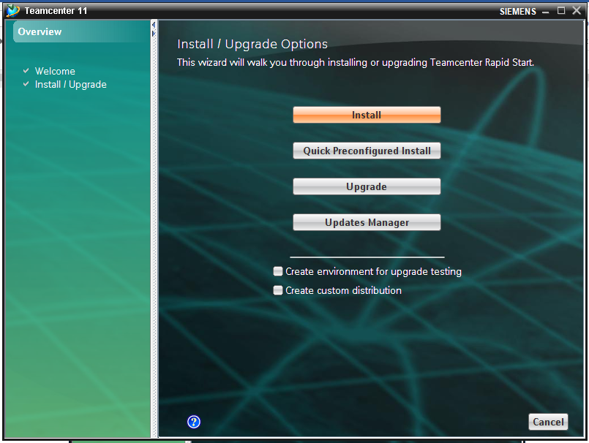

**4.** Give ID (TATADLTClient(No)) and Description (4TierClient(No))

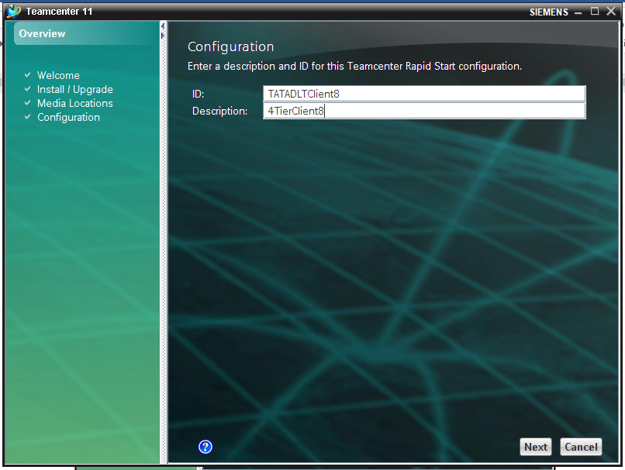

**5.** Select Rich Client 4-tier

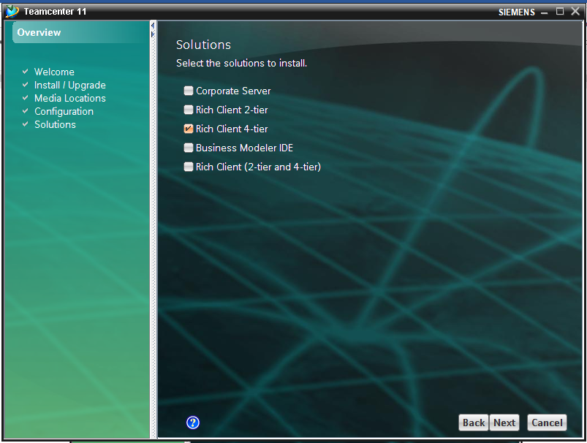

**6.** Give Installation directory (D:\SOFT\SPLM\4TClient)

**NOTE:** Do not create 4TClient folder manually

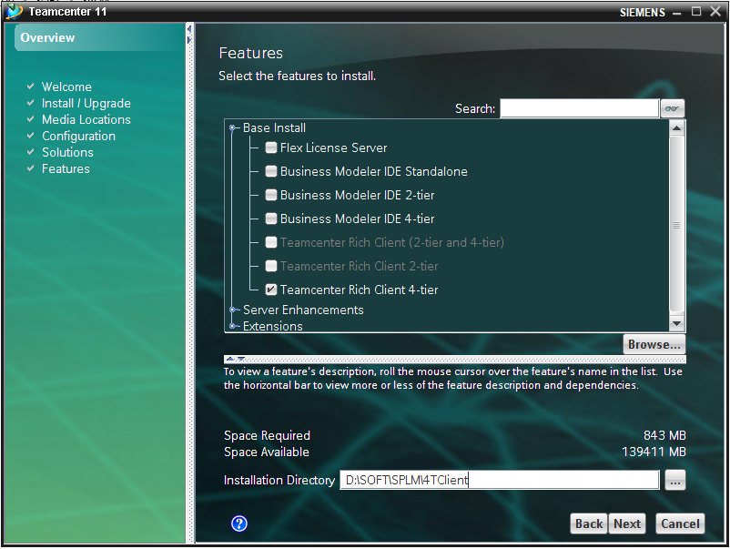

**7.** Fill Host as 192.168.1.195

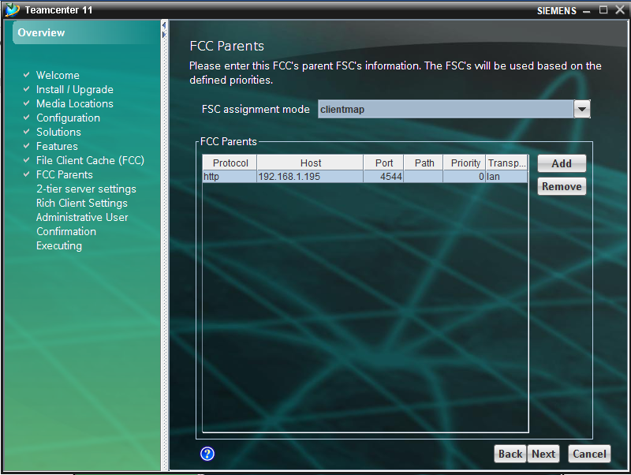

**8.** Give URL as **http://192.168.1.195:8080/tc**

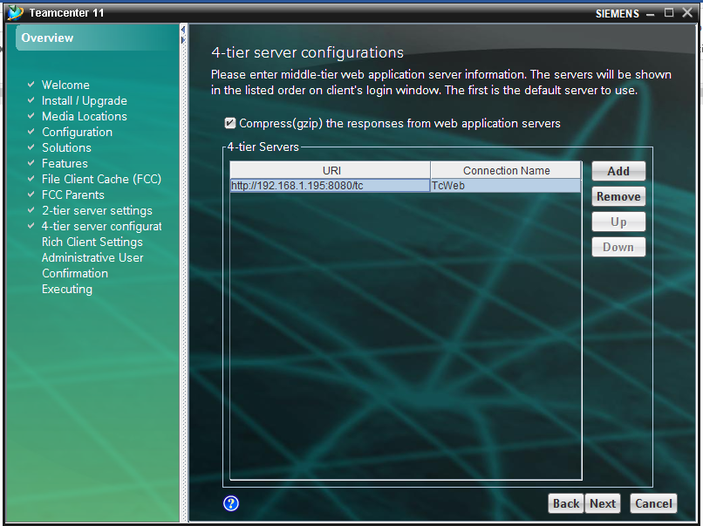

**9.** Select Next

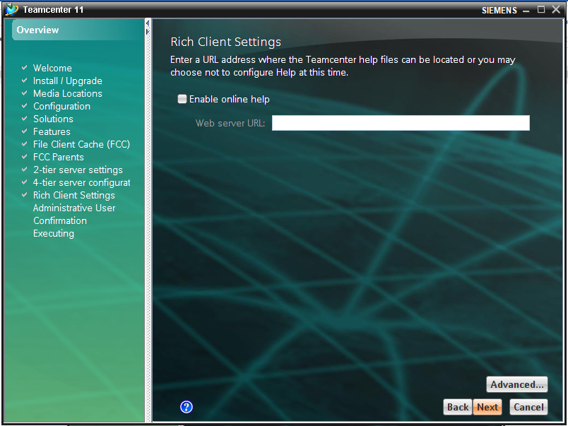

**10.** Give password as **infodba**

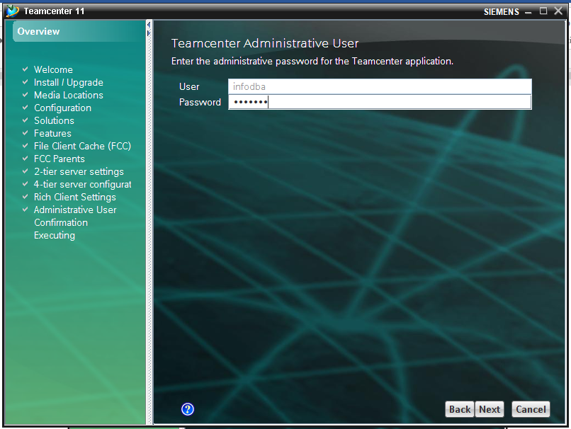

**11.** Click Start

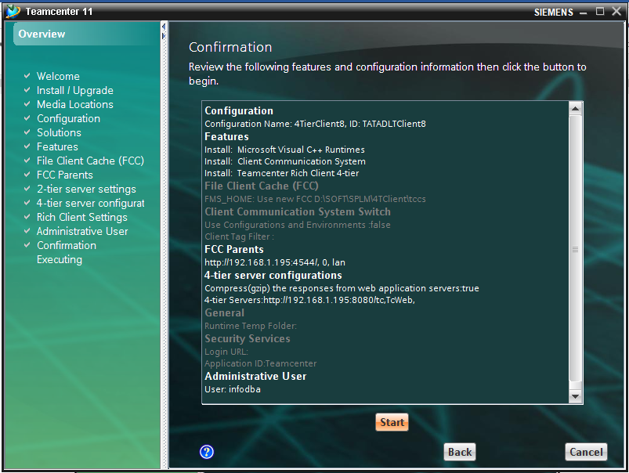

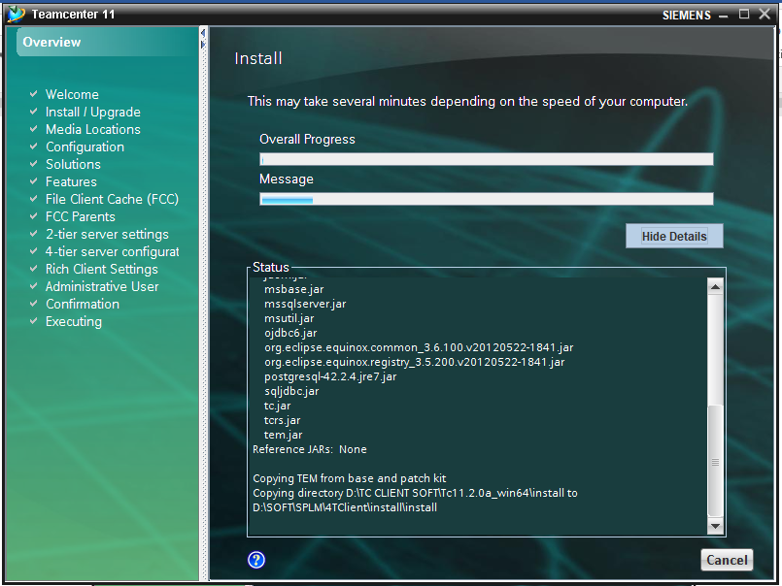

**12.** Successfully installed.

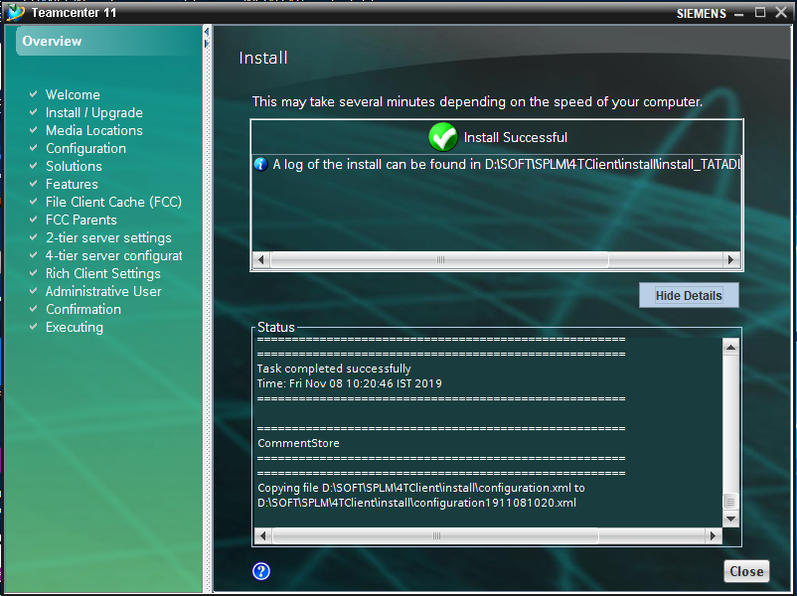

**13.** Create Environment variables (FMS_HOME) in System Variables

